

## SCHOOL OF INFOCOMM TECHNOLOGY

Diploma in CSF, DS, IT

**Cloud Architecture and Technologies (CAT)**

**April 2023 Semester**

**Assignment 1**

**25% of CAT Module – (Individual 100%)**

**08 May – 21 May 2023 (Weeks 4 & 5)**

**Deadline for submission:**

**SOFTCOPY:** Submit in BrightSpace by 21 May 2023, 23:59 SGT

**Penalty for late submission:**

* **10%** of the marks will be deducted for each day (inclusive of Saturdays, Sundays and public holidays) after the deadline for softcopy submission.

1. **Objectives**

The objective of this assignment is to assess students’ understanding of Cloud Infrastructure to implement a given business’ requirement in AWS.

1. **Scope**

The students will be assessed on their ability to:

1. Deploy 2 web servers in N. Virginia
2. EC2 (Web service) must be resilient to natural disasters
3. EC2 (Functioning as Web Application Servers) will auto-scale to meet higher traffic demands
4. A cloud object-storage service for public access
5. A cloud object-storage service for internal-only use
6. A NoSQL database with the following fields:
   * Username
   * Password
   * Email address
7. **Deliverables** 
   1. **Word document** explaining your design. Include:
8. Network Diagram of the solution
9. An explanation of the network design
10. Screenshot of the NoSQL database containing your student email
11. Name your file **<Name per attendance sheet>.assignment1.**docx
12. Video of ec2 screen showing auto-scaling of servers under network traffic load.
    1. Implement the above cloud requirements using AWS services with your AWS academy account.

Other specific requirements include:

* The elastic web service that starts with 2 (EC2) servers but can scale to 3 servers when demand increases. This web server just requires a general-purpose server with the following requirements:

• Runs on any Linux operating system

• 1 virtual CPU

• 1G of RAM

• 8GB of storage for the boot drive

• Low network performance requirement

* Note: Load balancing is ***not*** required.
* A reliable cloud storage space to provide the **public** with marketing material to download. The storage bucket should be called <studentname>-marketing. Upload any lecture slides into the bucket. Ensure that it is accessible to the public.
* The storage bucket for **internal** use should be called <studentname>- internal. Upload the video of Ec2 showing auto-scaling of servers under network load to this bucket.

Note the following:

• **DO NOT LOGIN** TO THE AWS CONSOLE AFTER THE DUE DATE OF SUBMISSION UNTIL YOU ARE GIVEN PERMISSION TO DO SO BY YOUR TUTOR! DOING SO MAY CONSTITUTE AS CHEATING!

• **DO NOT** terminate or delete anything in your AWS academy account until told to do so by your tutor.

1. **Submission Procedure**

You are required to submit the **SOFTCOPY** in BrightSpace by **21 May 2023, 23:59 SGT**.

**10%** of the marks will be deducted for every day after the deadline for softcopy submission.

1. **Implementation Marking Scheme**

| **Requirements** | **Marks** |
| --- | --- |
| ***A) Network Diagram*** | *10* |
| ***B) Explanation of Solution*** | *10* |
| ***C) Features implemented*** | *80* |
| 1. 2 Servers 2. 2 AZ 3. Public S3 4. Private S3 5. Video uploaded to S3 6. NoSQL Database Created 7. NoSQL Fields 8. Autoscaling video | *10*  *10*  *10*  *10*  *10*  *10*  *10*  *10* |
| **Total** | 100 |

**Note – Suspend Auto Launch Process in Auto Scaler**

When performing Auto Scaling, it is important that students suspend the launch process after they have completed the auto-scaling. This is to ensure that the credit will not be drastically reduced as there may be many EC2 running at the same time.

The steps to suspend the auto launch of the EC2 instances in Auto Scaler Group:

**Step 1:**

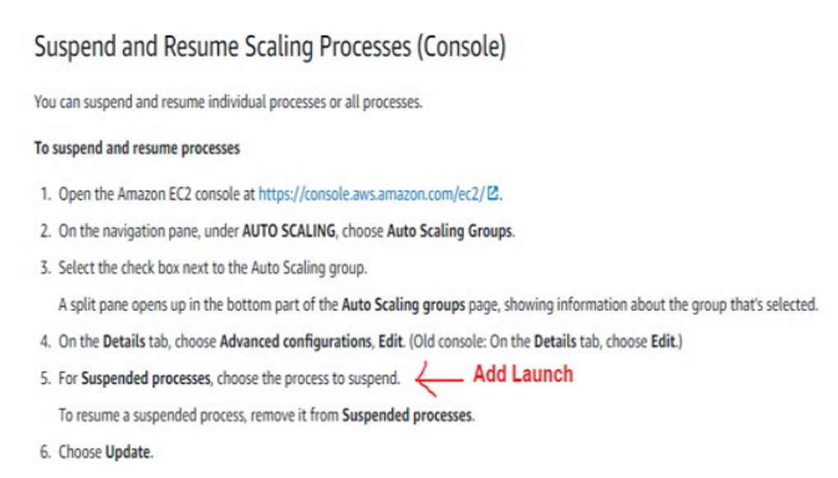

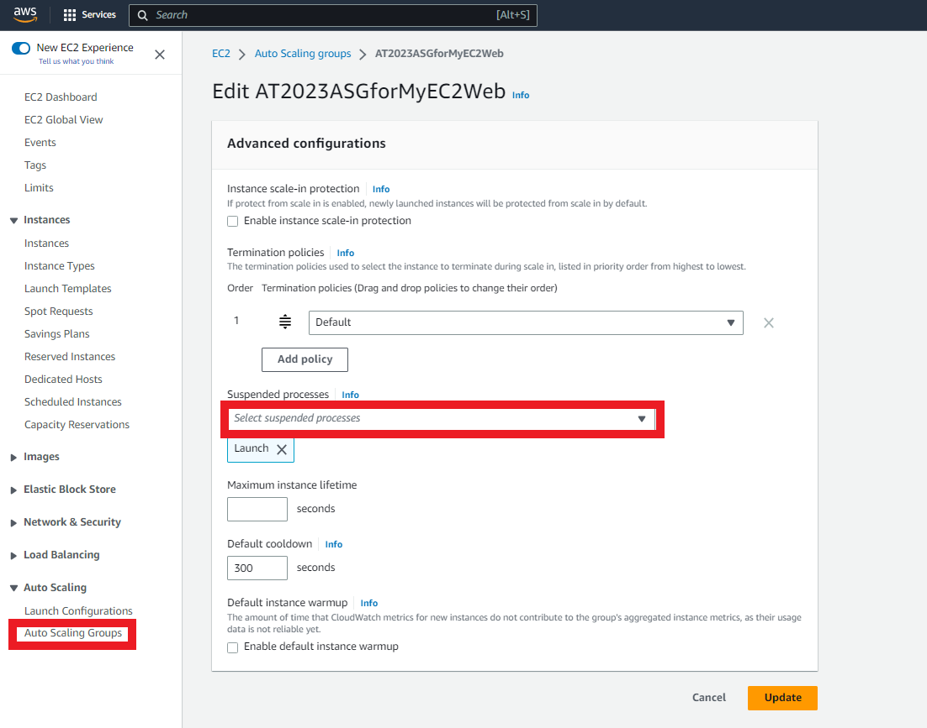

**Step 2:**

After step 1, remember to terminate (or stop) existing running EC2 instances.

Once the EC2 instances are terminated, auto scaler will not auto launch another EC2 instance as the launch process is suspended.

Once this suspension is removed, the autoscaler will launch the EC2 again. Tutor will remove the suspension to check if autoscaling is configured correctly.